CPE 322 Simulation 1

Esther Shore

February 2024

The file **eight_bit_sub_add_tb.v** contains the associated Verilog testbench. Below are screenshots of the waveform display and textual listing file outputs for the simulation for the period of time that the simulation was valid, in this case 800ns: 100ns for each of 8 test cases.

Starting from time zero, every 100ns interval, the next operation is performed, altering the values at each and maintaining them until the next interval mark as seen in Figure 1.

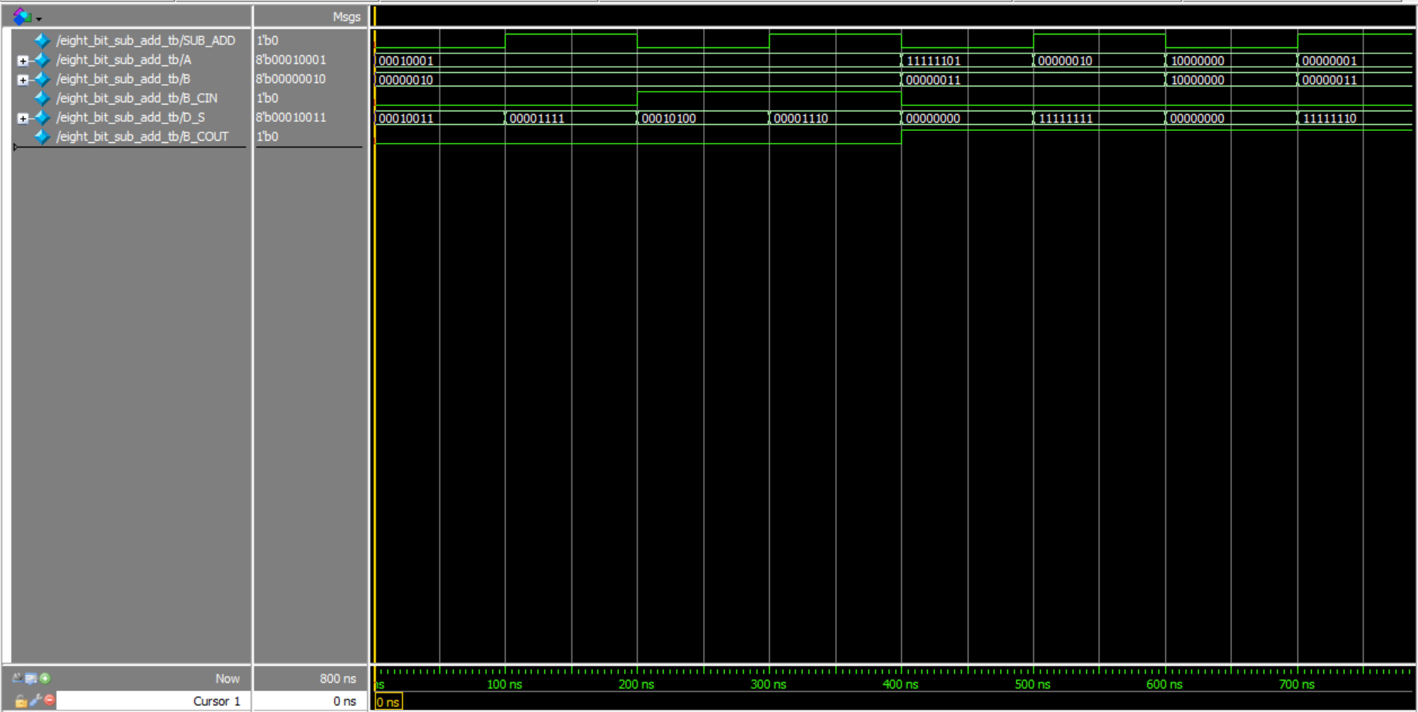

**Figure 1.** Waveform Output

On the time delta 0 of every 100ns interval, the inputs are loaded. Then, the outputs are calculated and loaded on time delta 1 for the same timestamp as seen in Figure 2.

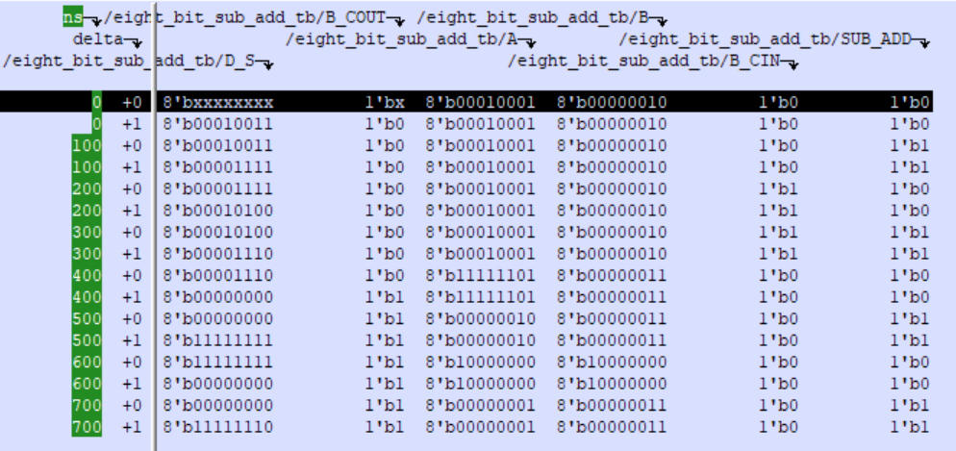

**Figure 2.** Textual Listing Output

**eight_bit_sub_add_tb.v**

| // Eight-Bit Sub/Add Test Bench  `timescale 1ns/100ps  module eight_bit_sub_add_tb;  // internal wires and register declarations  wire [7:0] D_S;  wire B_COUT;  reg [7:0] A,B;  reg B_CIN, SUB_ADD;  // unit under test  eight_bit_sub_add UUT (.D_S(D_S), .B_COUT(B_COUT),  .A(A),.B(B), .B_CIN(B_CIN),.SUB_ADD(SUB_ADD));  initial  begin  // 1) Add no carry on B_COUT  SUB_ADD = 0; // Add mode  B_CIN = 0; // No Carry in  A = 17; // A = 8'b00010001  B = 2; // B = 8'b00000010  // D_S = A + B = 19 -- 8'b00010011  // 2) Subtract no borrrow on B_COUT  #100 // 100ns delay  SUB_ADD = 1; // Subtract mode  B_CIN = 0; // No Borrow in  A = 17; // A = 8'b00010001  B = 2; // B = 8'b00000010  // D_S = A - B = 15 -- 8'b00001111  // 3) Add with pending carry on B_CIN  #100 // 100ns delay  SUB_ADD = 0; // Add mode  B_CIN = 1; // Carry in  A = 17; // A = 8'b00010001  B = 2; // B = 8'b00000010  // D_S = A + B + B_CIN = 20 -- 8'b00010100  // 4) Subtract with pending borrow on B_CIN  #100 // 100ns delay  SUB_ADD = 1; // Subtract mode  B_CIN = 1; // Borrow in  A = 17; // A = 8'b00010001  B = 2; // B = 8'b00000010  // D_S = A - B - B_CIN = 14 -- 8'b00001110  // 5) Add where internal carry propagates from LSB to B_COUT  #100 // 100ns delay  SUB_ADD = 0; // Add mode  B_CIN = 0; // No Carry in  A = 253; // A = 8'b11111101  B = 3; // B = 8'b00000010  // D_S = A + B = 256 -- 8'b00000000, B_COUT = 1  // 6) Subtract where borrow propagates from LSB to borrow request on B_COUT  #100 // 100ns delay  SUB_ADD = 1; // Subtract mode  B_CIN = 0; // Borrow in  A = 2; // A = 8'b00000010  B = 3; // B = 8'b00000011  // D_S = A - B = -1 -- 8'b11111111, B_COUT = 1  // 7) Add that causes an overflow into the carry bit  #100 // 100ns delay  SUB_ADD = 0; // Add mode  B_CIN = 0; // No Carry in the input from a previous stage  A = 128; // A = 8'b10000000  B = 128; // B = 8'b10000000  // D_S = A + B = 256 -- 8'b00000000, B_COUT = 1  // 8) Subtract larger positive number from smaller positive number  #100 // 100ns delay  SUB_ADD = 1; // Subtract mode  B_CIN = 0; // No Borrow in the input from a previous stage  A = 1; // A = 8'b00000001  B = 3; // B = 8'b00000011  // D_S = A - B = -2 -- 8'b11111110, B_COUT = 1  end  endmodule |
| --- |